**CENWP-OD-B 08 July 2022**

**MEMORANDUM FOR THE RECORD**

**SUBJECT: 22BON033 MFR AFF Sockeye and Smolt Mort**

On 07 July, Columbia River Inter-Tribal Fish Commission (CRITFC) Biologists notified Bonneville Project Biologists of one adult sockeye mortality and a salmon smolt mortality found on the Valve 15 trash rack in the Adult Fish Facility (AFF). The fish mortalities were scanned for PIT tags, inspected, and returned to the river.

**Adult sockeye mortality:**

1. Species – Sockeye (*Oncorhynchus nerka*)
2. Origin – NA
3. Length – approximately 51 cm
4. Marks and tags – No tag, unable to determine adipose fin presence due to state of decay
5. Marks and Injuries found on carcass – NA, very decayed
6. Cause and Time of Death – Unknown time, discovered on 07 July
7. Future and Preventative Measures – None

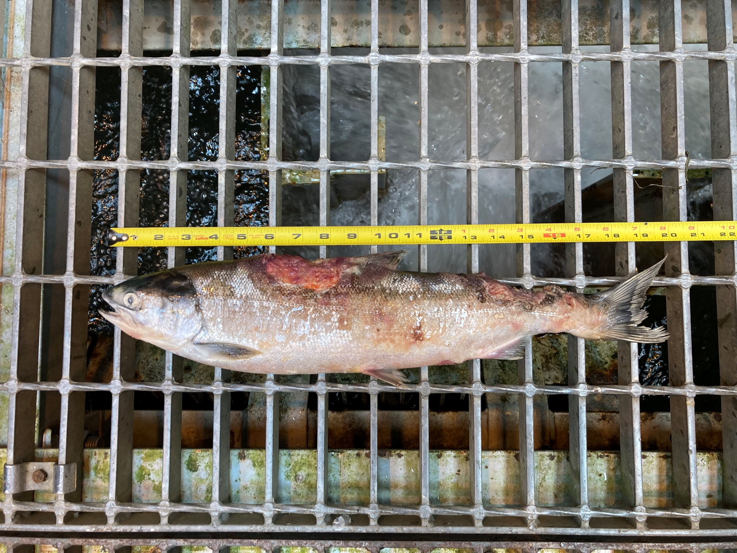

**Smolt mortality:**

1. Species –*Oncorhynchus* smolt
2. Origin – NA
3. Length – approximately 25 cm
4. Marks and tags – No tag, clipped adipose
5. Marks and Injuries found on carcass – NA
6. Cause and Time of Death – Unknown time, discovered on 07 July
7. Future and Preventative Measures – None

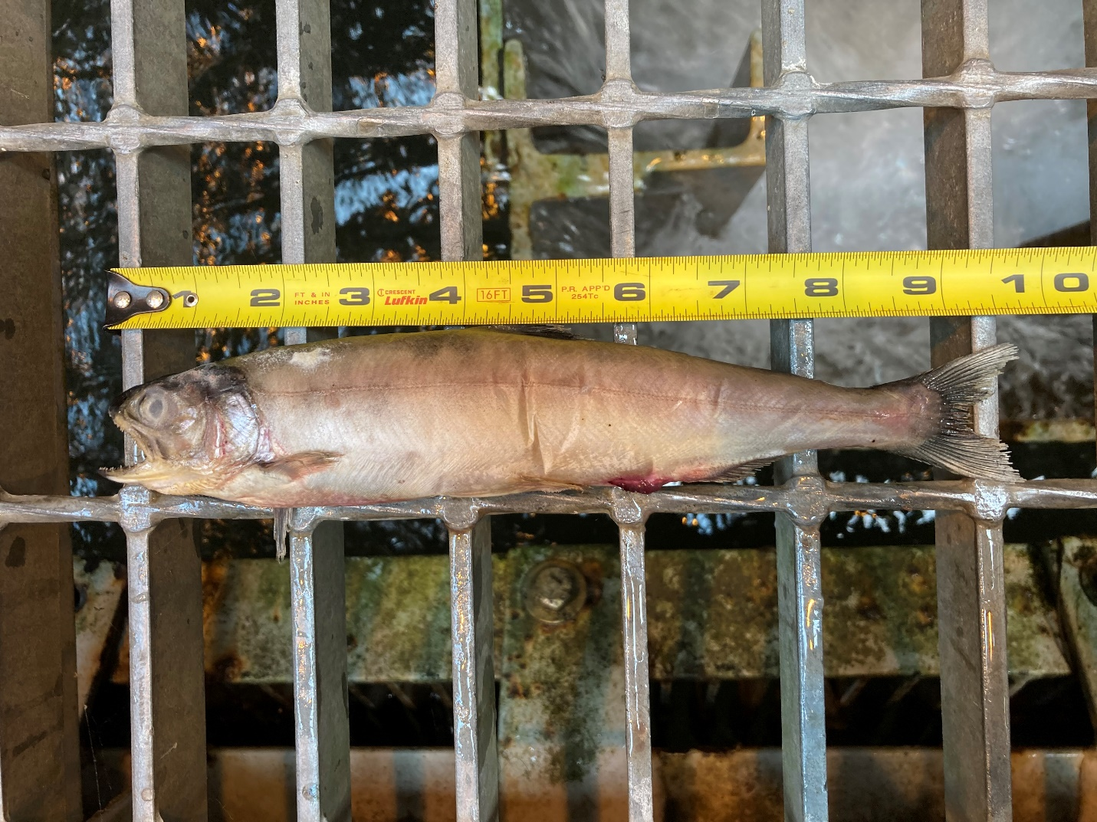

Sincerely,

Bonneville Project Fisheries